# Unit 1 Assignment: Agile Methodologies

# Amon-ra

# Herzing University

BU 624-7 Systems Analysis and Design

Agile Methodology is set of values as opposed to being an actually method. It can be thought of as more of a mindset and serves as a guideline.

Those values are:

1. Individuals and interactions over processes and tools
2. Working software over comprehensive documentation
3. Customer collaboration over contract negotiation
4. Responding to change over following a plan ("What is Agile Software Development?", 2019)

The goal of this mindset is to be agile, hence the name agile methodology. Agile is defined by Merriam-Webster dictionary as “1: marked by ready ability to move with quick easy grace. 2: having a quick resourceful and adaptable character.” ("Agile, n.d."). Thus agility is the power to move quickly.

Upon pondering the definition of agile, what immediately comes forth in my mind, is the superhero character Spiderman. This character is very agile. He springs into action by flipping, swinging, dodging, bouncing, rolling, twisting, moving in ways to adapt his body for maximum success when taking the day’s challenges as a superhero. “Agile is the ability to create and respond to change. It is a way of dealing with, and ultimately succeeding in, an uncertain and turbulent environment.” ("What is Agile Software Development?", 2019) Agile is does not apply a methodology for is would then not be agile and become rigid.

1. Our highest priority is to satisfy the customer through early and continuous delivery of valuable software.
   1. This value emphasizes getting the product to market without delays with constant and improves delivered through upcoming releases and updated versions.
2. Welcome changing requirements, even late in development. Agile processes harness change for the customer's competitive advantage.
   1. The second principle advises to open to change even if in the final stages before release for it is for the customer’s benefit and Agile is customer focused.
3. Deliver working software frequently, from a couple of weeks to a couple of months, with a preference to the shorter timescale.
   1. Improvements to the software need not be long-awaited. Strive for more frequent updated releases.
4. Business people and developers must work together daily throughout the project.
   1. Business people know what functions they are preforming and by communicating this to the developers, the project can be created to accomplish what is needed.
5. Build projects around motivated individuals. Give them the environment and support they need, and trust them to get the job done.
   1. There is no need to convince motivated people and if projects are built around them it will have the best chance of success for they believe in it. Provide them with the needed resources and allow them to work toward the goal.
6. The most efficient and effective method of conveying information to and within a development team is face-to-face conversation.
   1. Working within close proximity of the team is good for communication. In my department, we once had cubicles. The cubicles were replaced by desk that have a 30-degree angular shape. Three of those desks would be placed together to form a cluster of three team members. The entire department now has this open concept to allow people communicate face-to-face.
7. Working software is the primary measure of progress.
   1. Producing functional software is the ultimate proof of success of the project. This speaks to proof being in the results.
8. Agile processes promote sustainable development. The sponsors, developers, and users should be able to maintain a constant pace indefinitely.
   1. This reflects back to frequent and constant delivery of software and includes the involvement of sponsors, developers, and users.
9. Continuous attention to technical excellence and good design enhances agility.
   1. Agility isn’t simply change but change that fosters technical excellence and good design.
10. Simplicity--the art of maximizing the amount of work not done--is essential.
    1. It’s easy to focus on the amount of work completed yet what would really drive the project is focusing on the amount of work that is not completed. Efforts should be made to minimize the amount of work that remains allows the greatest effectiveness.
11. The best architectures, requirements, and designs emerge from self-organizing teams.
    1. Team members know their own strengths and passions and will contribute to the project accordingly. By allow the team to organize itself, the best arrangement is made possible.
12. At regular intervals, the team reflects on how to become more effective, then tunes and adjusts its behavior accordingly. ("What is Agile Software Development?", 2019)
    1. Periodic self-inventory of the shortcomings of the team helps to identify areas that need improvement. Thus, the team itself is agile and makes improvements in order to be more effective and efficient.

System analysis and design is meeting business requirement via an information system composed information technology, people and data. The advantages of the Agile methodology in regards to system analysis and design allows for the infinite and frequent increase of information system.

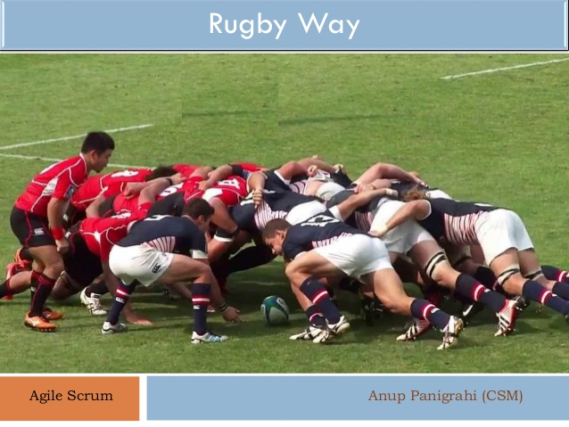 Panigrahi, A (Photographer). (2017, May 9). Agile scrum rugby way. https://www.slideshare.net/AnupPanigrahi/agile-scrum-rugbyway

SCRUM is a methodology within the Agile framework. The term was first used by Hirotaka Takeuchi and Ikujiro Nonake. The pair adopted the name from an action in the game of rugby in which the individual members of the team come together. Thus, SCRUM symbolizes a team working tightly together like one unit to achieve the desired goal. SRUM seeks to pull together a team to accomplish the frequent project software updates.

SCRUM can be thought of as projects within projects or a series of projects. It is time conscious for projects are short and restricted to a time-frame. Each project follows the next project with no break in between. Information is carried over into the next project and updates are provided to sponsors at the conclusion of each project.

## References

Agile. (n.d.). Retrieved January 11, 2020, from https://www.merriam-webster.com/dictionary/agile

Panigrahi, A. (2017, May 9). Agile scrum rugby way. Retrieved from https://www.slideshare.net/AnupPanigrahi/agile-scrum-rugbyway.

Ramakrishnan S (2012) System Analysis and Design. J Inform Tech Soft Engg S8: e001. doi:10.4172/2165-7866.S8-e001

Shead, M. (2018, August 22). What is Agile Methodology? Retrieved from https://www.youtube.com/watch?v=ZZ_vnqvW4DQ

Spider-Man (Peter Parker) In Comics Powers, Villains, Enemies: Marvel. (n.d.). Retrieved January 11, 2020, from https://www.marvel.com/characters/spider-man-peter-parker/in-comics

Sutherland, J. (2012, April 2). The Scrum Papers: Nut, Bolts, and Origins of an Agile Framework <http://jeffsutherland.org/scrum/ScrumPapers.pdf>

What is Agile Software Development? (2019, December 20). Retrieved from https://www.agilealliance.org/agile101/